Geogenic Metal Contaminants in Groundwater: Sources, Fate, and Potential Health Impacts of Lead, Uranium, Manganese, and Arsenic
- Focus on policy
- *** Add abstract: 250 words
- Finish introduction: What story do I want to tell – This is how metals get into groundwater, this is the importance, and here are the health effects, for policy
  - Relate to policy
    - Impact on legislation
    - Stakeholders and stakeholder engagement
    - Potential policies around testing
  - Problem statement
    - *Again this will differ depending on journal targeted. How do I combine them to target all three?
    - The presence of geogenic metal contaminants such as lead, uranium, manganese, and arsenic in groundwater presents multifaceted challenges that extend beyond their well-documented origins and environmental behavior. Despite significant scientific advancements, a critical gap persists in the translation of this knowledge into effective policy frameworks and practical environmental management strategies. This review synthesizes the latest research to provide an integrated understanding of these contaminants' sources, transport mechanisms, ecological impacts, and health risks. By doing so, it aims to bridge the divide between science and policy, informing decision-making processes at multiple levels to enhance public health protection, promote sustainable water resource management, mitigate environmental risks, and foster ecosystem resilience through informed policy decisions, comprehensive remediation strategies, and holistic environmental assessments.
  - Uniqueness/relevance
    - How is this unique? Inclusive of Canada, uranium
    - Integration of Science and Policy: The review uniquely integrates scientific findings with their policy implications, providing a direct pathway from research to actionable policy development
    - Global Relevance: It addresses contaminants that are of global concern, making the review's findings applicable and useful across different geographical contexts,
    - Multidisciplinary Approach: The review combines insights from environmental science, health sciences, and policy analysis, which is increasingly important in addressing complex environmental issues where interdisciplinary solutions are needed.
    - Filling Knowledge Gaps: By focusing on geogenic contaminants, the review tackles an area often overshadowed by anthropogenic pollution, providing new insights into naturally occurring contaminants that have been less studied in terms of policy and health impacts.
  - Current knowledge
    - Add policies?
    - Health, geology
  - Research gaps
    - anthropogenic pollution often receives attention, naturally occurring contaminants are frequently overlooked in policy discussions.
    - Need for a comprehensive review that integrates health outcomes with environmental exposure.
    - Gap of understanding the complete environmental cycle of these contaminants especially uranium.
  - Purpose
    - To assess the metal’ influence on biogeochemical cycles.
    - To evaluate the health implications of these contaminants.
    - To synthesize the current knowledge on sources, fate, and health impacts of these metals in groundwater. (Basically the two above)
    - To provide policy recommendations for better management and mitigation.
  - Scope:
    - Should I add in covering international, national, and local policy implications?
    - Global relevance focused on public health outcomes
    - Environmental science and geology
- Relate each paragraph to policy. Heavily related health effects to policies
- Add it 1 new diagram. Remove diagrams from Nova scotia, Add in lead in states diagram
- Add more relevant case studies: Specific recent geogenic contamination events
- Finish conclusion
  - Add policy recommendations
- Journals to target:
  - 1) Environmental Science & Policy: policy implications
  - 2) Environmental Health Perspectives: health impacts
  - 3) Science of The Total Environment: comprehensive environmental impacts
- )
Groundwater is a critical and irreplaceable freshwater resource, serving as the primary source of drinking water for billions of people worldwide. As global demand for water continues to rise due to factors such as climate change, droughts, and population growth, the reliance on groundwater for domestic, agricultural, and industrial uses has become increasingly paramount ***.
While the contamination of groundwater by pathogenic microorganisms is often the primary focus of concern in drinking water, another significant threat to water quality that warrants equal attention is the presence of heavy metals. Unlike microbial contaminants, which may be more readily detected and addressed, heavy metals can persist in the environment and bioaccumulate within the human body, leading to chronic health conditions ***. The sources, mobilization, and impacts of geogenic heavy metal contamination in groundwater are often less understood and can be overlooked in comparison to other water quality issues ****.
Heavy metals, such as lead, uranium, manganese, and arsenic, are a class of dense, naturally occurring elements that pose significant health risks due to their potential for toxicity and bioaccumulation. These contaminants can enter groundwater systems through both anthropogenic sources, such as industrial activities, agricultural practices, and improper waste disposal, as well as geogenic sources resulting from the weathering and dissolution of metal-bearing minerals within the Earth's crust *****.
This review aims to provide a comprehensive examination of the key aspects of heavy metal contamination in groundwater resources with a focus on lead, uranium, arsenic and manganese. The identification of primary geogenic sources, including the weathering and dissolution of metal-bearing minerals, will be a focal point. The underlying hydrogeochemical processes governing the mobilization and transport of heavy metals within groundwater systems will be thoroughly explored. Additionally, the review will analyze the health impacts of heavy metal exposure on vulnerable populations, such as children, pregnant women, and the elderly, as well as the potential for synergistic effects when multiple heavy metals are present. While the primary focus will be on geogenic sources, the review will also consider the potential contributions of anthropogenic activities, such as industrial, agricultural, and well structures, to heavy metal contamination in groundwater.
Addressing geogenic heavy metal contamination, particularly from naturally occurring sources like lead, poses distinct challenges compared to anthropogenic sources ***. The natural occurrence of these contaminants within the geological environment can be more complex to identify and mitigate **. This review seeks to highlight the importance of addressing geogenic sources, as they can have significant and long-lasting impacts on groundwater quality and human health. The investigation of the influence of morphological and lithological characteristics on the distribution and concentration of heavy metals, including lead, within groundwater systems will provide crucial insights.
The findings from this comprehensive examination will be essential for informing policy decisions and regulatory frameworks aimed at protecting public health and ensuring the long-term availability of safe, clean groundwater supplies. The evidence generated will equip policymakers, water resource managers, and public health officials with the necessary knowledge to develop and implement effective policies, guidelines, and intervention strategies to mitigate the risks posed by geogenic heavy metal contamination in groundwater. Understanding the geogenic factors governing heavy metal contamination, such as the weathering and dissolution of metal-bearing minerals, is crucial for guiding the development of targeted remediation strategies and the sustainable management of this vital water resource.
- Add in paragraph about policies

Geogenic Metals in Geological Formations as s Source of Metal Contamination
Geological formations often contain minerals with heavy metals that may leach into groundwater, depending on the mineral composition of the surrounding rocks and soil, the local hydrogeological conditions, and the dual chemical characteristics of the aquifer [1]. This groundwater contamination can be attributed to various processes, including volcanic eruptions, rock weathering, and the leaching of metals into the groundwater through geochemical interactions that dissolve the present metals into the water.
Geological formations, such as sedimentary rocks like limestone, dolomite, or shale, can contain minerals with heavy metals that may leach into groundwater. This process is influenced by various factors, including the redox conditions, pH, and the presence of other minerals in the surrounding environment [2]. For instance, iron and manganese are commonly found in these rock formations, and their release into the groundwater is often promoted by conditions with high oxygen levels [1]. An example of this is the association between manganese and the Windsor Group limestone formation in Nova Scotia [3].
Similar groundwater contamination issues have been observed in other regions. In the Bengal delta of Bangladesh, sediments have been found to release elevated levels of arsenic [4]. Additionally, the High Plains Ogallala aquifer in the United States contains sedimentary rock formations associated with uranium, which can be leached into the groundwater under reducing conditions [5].
- Recently 3 primary studies
- Focus on Adsorption and co-precipitation, Dissolution and desorption
- Rock cycle: Weathering/erosion: Sed rocks act as a sink, weathering releases them
- Sedimentation and Deposition:
- Heavy metals released from weathered rocks can be transported and deposited in sedimentary environments, such as floodplains, lakes, and marine settings, where they can accumulate and be incorporated into sedimentary rocks.
- The heavy metal content in sedimentary rocks can be further concentrated through processes like adsorption, co-precipitation, and organic matter incorporation
Igneous and metamorphic rocks can also contain various trace metals, including uranium and radium, either as primary or accessory minerals [6]. Examples of such rocks include granite, syenite, basalt, gabbro, nepheline, and andesite [2]. In these cases, metal leaching is dependent on groundwater chemical factors, such as mineral solubility, rock-water interactions, and water infiltration through fractures or fissures.
Furthermore, volcanic activity can release heavy metals like lead, mercury, and arsenic, which are then transported into nearby soils and sediments. Subsequent groundwater interactions with these metal deposits can result in further metal leaching [1]. Examples of this phenomenon include arsenic contamination in groundwater in the Andean region of Argentina and Chile, as well as manganese contamination from basaltic formations in aquifers in India [7,8].
- 3 primary studies
Conceptually, these rock cycle processes related to arsenic contamination can be associated with the metamorphism, volcanic emissions, and hydrothermal activities depicted in Figure 2.1.1 [1].
- 3 primary studies
- Uplift, Erosion, and Recycling:
- Tectonic processes, such as uplift and erosion, can expose previously buried rocks (sedimentary, igneous, or metamorphic) to weathering and erosion, allowing the heavy metals to re-enter the rock cycle.
- This recycling of heavy metals through the rock cycle can continue indefinitely, with the metals being continuously redistributed and potentially concentrated in different geological environmen
- How it can affect policies ****
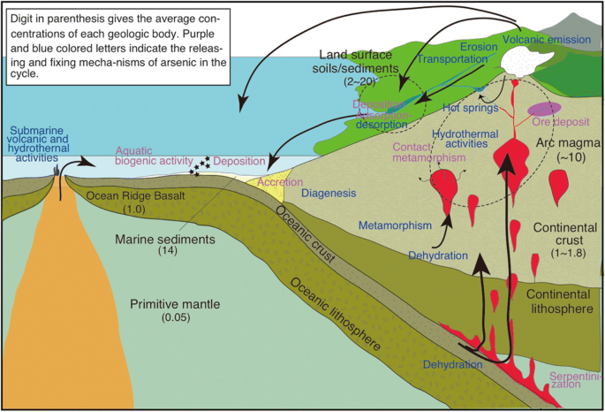
Figure 2.1.1: Arsenic geologic cycle. Digit in parenthesis gives the average concentrations of each geologic body. Purple and blue colored letters indicate the releasing and fixing mechanism of arsenic in the cycle. [9].

Anthropogenic sources as Drivers of Metal Contamination in Groundwater Systems

Anthropogenic Sources of Metal Groundwater Contamination activities can significantly increase the levels of metal contaminants in water resources, particularly groundwater and well water. Emissions, effluents, and waste disposal from mining, smelting, manufacturing, and other industrial processes can release various metals into the environment. These metals can then enter groundwater systems through surface runoff, infiltration, or direct contamination [10].

In the Canadian context, mining activities are a major source of groundwater contamination. For instance, the mining operations in the Sudbury region of Ontario have led to the contamination of groundwater with elevated levels of copper, nickel, and cobalt [11,12]. A similar situation exists in the United States, where the groundwater in the Silver Valley region of Ohio and Idaho has been affected by lead, zinc, and other metal contamination due to mining activities [13].

Furthermore, groundwater can also be contaminated by agricultural practices, such as the use of fertilizers, pesticides, and animal waste. These agricultural inputs can leach into the groundwater and contribute to the overall metal contamination through groundwater recharge processes [14].
- Add in policies

The release of metals from anthropogenic sources, including industrial activities and agricultural practices, can have significant implications for the quality of groundwater resources and the health of surrounding communities that rely on these water sources.
The Influence of Well Infrastructure and Piping Materials on Groundwater Metal Contamination
In addition to anthropogenic sources such as industrial activities and agricultural practices, the deterioration of well infrastructure and the corrosion of piping materials can also contribute to metal contamination in groundwater [15]. The critical components of a well, including pipes, fittings, and pumps, can be constructed from materials such as lead, copper, and zinc, which can gradually corrode over time and release these metals into the water flow.
***** 2 primary examples

Furthermore, the presence of rusted iron oxides in the well system can have a complex influence on groundwater contaminant levels. While these iron oxides may have the ability to reduce or remove certain contaminants, such as arsenic, through adsorption or co-precipitation processes similar to those observed in soil environments [16], the overall effect on the geochemical composition of the groundwater can be variable and dependent on site-specific conditions.
*** one primary example. Policies
The mobilization of metals from the degradation of well infrastructure and the potential for iron oxides to interact with groundwater contaminants underscores the importance of considering the hydrogeochemical characteristics of the well system when evaluating sources and pathways of metal contamination in groundwater. Addressing these infrastructure-related factors is crucial for developing effective strategies to mitigate the impact of metal pollutants on groundwater resources.
Geogenic and Anthropogenic Sources of Metals in Groundwater and Well Water
The specific metals found as contaminants in groundwater and well water are largely dependent on the local geography, geology, and hydrochemical characteristics of the aquifer system [17]. In Nova Scotia, common metal contaminants include manganese, arsenic, magnesium, lead, uranium, and fluoride, reflecting the regional geological composition. Internationally, arsenic, cadmium, selenium, and copper are also frequently encountered as groundwater pollutants [18].
Lead contamination in groundwater and well water is a particular concern due to its potential health impacts, especially on pregnant women and children [19]. The primary source of lead in these water resources is often the leaching of lead from plumbing materials, such as pipes and fittings, within the distribution system. This process can be exacerbated by factors like low pH and prolonged contact time [20]. Geologically, lead may also be present in the form of galena (lead sulfide) in hydrothermal veins and mineral deposits, which can undergo dissolution and reprecipitation as lead carbonate (cerussite) under oxidizing conditions, leading to groundwater contamination [21].
**** Add in lead contamination diagram
Add geogenic lead primary examples
Add policies
Similarly, zinc contamination in well water and drinking water systems is commonly attributed to the corrosion of galvanized iron or zinc-coated plumbing materials, particularly in low pH or acidic conditions [22]. Groundwater contamination by zinc can also occur through the erosion and deposition of zinc-containing sediments, as well as volcanic emissions in regions with active volcanism [22].
Copper contamination in groundwater is typically associated with the corrosion of copper plumbing materials, including pipes, fittings, and fixtures, facilitated by factors such as acidic water, high chlorine levels, and prolonged contact time [23]. However, in specific geochemical settings, copper contamination can also arise from the weathering and dissolution of natural copper-bearing minerals, such as chalcopyrite, malachite, and azurite, which are found in hydrothermal veins, porphyry deposits, and other geological formations [11]. Regions with high natural copper mineralization, such as Cyprus and the western United States, are particularly prone to this type of groundwater contamination.
In contrast, iron contamination in groundwater can originate from both natural sources and the corrosion of iron plumbing materials, although it is more of an aesthetic concern than a health issue [24].
- Should I remove Cu and Fe? Or just add policies around wells
Other metal contaminants, such as mercury and cadmium, are primarily associated with anthropogenic activities. Mercury contamination in groundwater can arise from coal combustion, industrial discharges, mining, and the deposition of atmospheric mercury, as well as from natural geological sources, including mercury-bearing minerals like cinnabar and volcanic emissions [25,26]. Cadmium contamination, on the other hand, is primarily linked to anthropogenic activities, such as mining, phosphate fertilizer production, improper waste disposal, and industrial discharges, though it can also be enhanced by the weathering and erosion of sphalerite and volcanic activity [27].
- Remove Cd add policies
In summary, the presence and distribution of metal contaminants in groundwater and well water systems are the result of a complex interplay between geogenic (natural geological) and anthropogenic (human-induced) sources and processes, which must be carefully considered when addressing groundwater quality concerns.
Uranium Contamination in Groundwater: Geogenic and Anthropogenic Influences
Uranium can be introduced into groundwater systems through both anthropogenic and natural geogenic processes. While anthropogenic pollution can contribute to uranium contamination, the element is also naturally associated with igneous and metamorphic geological formations [1].
The primary sources of natural uranium in groundwater are the weathering and dissolution of uranium-bearing minerals, such as uraninite (pitchblende) and coffinite [28]. This process is particularly prevalent in aquifer systems like the High Plains and Central Valley aquifers in the United States (Figure 2.1.2), where uranium release may be further enhanced by biotic nitrate reduction. Additionally, the weathering of sedimentary deposits, such as sandstones, can also lead to elevated uranium levels in groundwater. In Nova Scotia, uranium has been identified as a significant risk factor in well water, with the bedrock geology being the dominant control on its distribution [17] (Figure 2.1.3).
The release of uranium into groundwater is primarily driven by natural weathering and dissolution processes, which are influenced by factors such as pH and redox conditions [29]. Mineral release is often the controlling factor for groundwater uranium contamination, with de-adsorption from mineral surfaces and the associated reaction kinetics, oxidation conditions, and thermodynamics playing a crucial role.
Certain mineral phases, such as iron and magnesium oxides (e.g., goethite, hematite, and ferrihydrite), have the ability to adsorb uranium ions, thereby reducing their mobility and transport in groundwater [30]. Reductive precipitation can also serve to immobilize uranium in the subsurface [29]. Conversely, the presence of organic matter, including humic and fulvic acids, can form stable uranium complexes, facilitating the enhanced transport and mobility of uranium in the groundwater system [31]. Additionally, the formation of uranium complexes with carbonate minerals, such as calcite or dolomite, can also increase the solubility and mobility of uranium in the aqueous phase.
- Add policies and policies history
The understanding of these geochemical processes and the identification of the primary sources, both anthropogenic and geogenic, are crucial for the effective management and remediation of uranium contamination in groundwater resources.
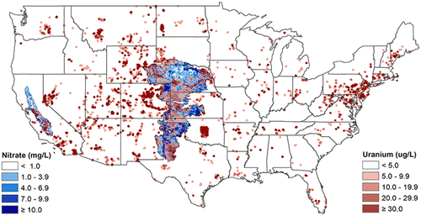
Figure 2.1.2: A map of uranium (red) and nitrate (blue) concentrations for groundwater aquifers in the US [28].
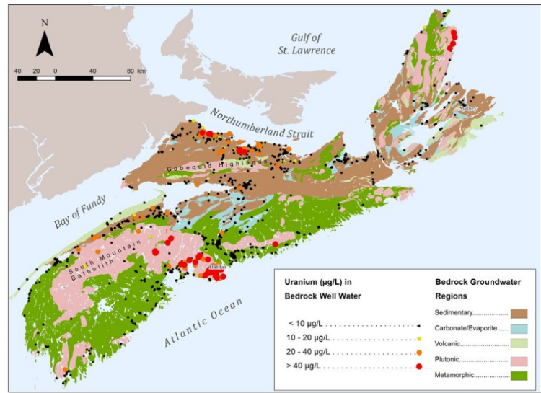
Figure 2.1.3: Uranium in well water/groundwater for Nova Scotia [17].

Geogenic and Anthropogenic Arsenic Contamination of Groundwater
Arsenic contamination in groundwater can arise from both anthropogenic and natural geogenic sources. While anthropogenic activities can contribute to arsenic pollution, a significant portion of groundwater arsenic contamination is driven by the natural weathering and release of arsenic-bearing minerals from geological formations [2].
Some of the primary arsenic-containing minerals that can release the metalloid into the surrounding environment include arsenopyrite (an iron-arsenic sulfide) and pyrite, which are commonly found in hydrothermal mineral deposits [32]. Arsenic can also be naturally present in volcanic deposits and sedimentary environments, such as alluvial aquifers or deltaic settings [4].
The prevalence of geogenic arsenic contamination in groundwater has been well-documented in various regions. In Nova Scotia, arsenic levels in groundwater have been found to be strongly influenced by the local bedrock geology, with higher arsenic concentrations associated with drilled wells compared to dug wells or surface water sources [33] (Figure 2.1.5).
Similar patterns have been observed in other parts of the world. The United States Geological Survey (USGS) has reported that approximately 7% of sampled wells exceeded the 10 μg/L arsenic standard, particularly in the southwestern United States and the Glacial aquifer system in the northern United States [34]. Specific areas of concern include the Pinemont Blue Ridge and Valley area in the eastern Appalachian region, the Texas coastal upland aquifer system, and the Mississippi River alluvial valley aquifer in the southeastern United States (Figure 2.1.4). In these regions, the primary source of arsenic is often attributed to the weathering and dissolution of arsenic-bearing minerals in volcanic and granitic bedrock, facilitated by factors such as groundwater residence time, high pH, arid climate, and the overall geochemical characteristics of the aquifer system [34].
Internationally, the Bengal Delta region of Bangladesh and West Bengal, India, has experienced a severe arsenic contamination crisis, with the arsenic being derived from the Himalayan sediments that make up the deltaic environment [4]. This has led to widespread exposure and significant public health concerns for the affected populations.
- Add policies
Comprehending the geogenic sources, mobilization mechanisms, and hydrogeochemical drivers of arsenic contamination in groundwater is pivotal for developing effective mitigation and management strategies to address this persistent environmental challenge.
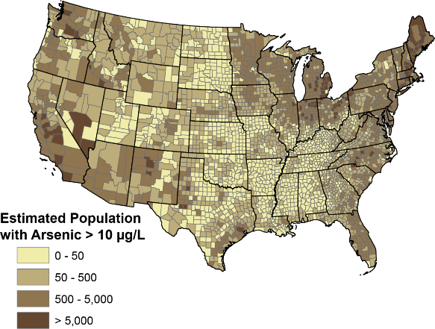
Figure 2.1.4: Estimations of private well users in U.S. counties that are contaminated with Arsenic [34].
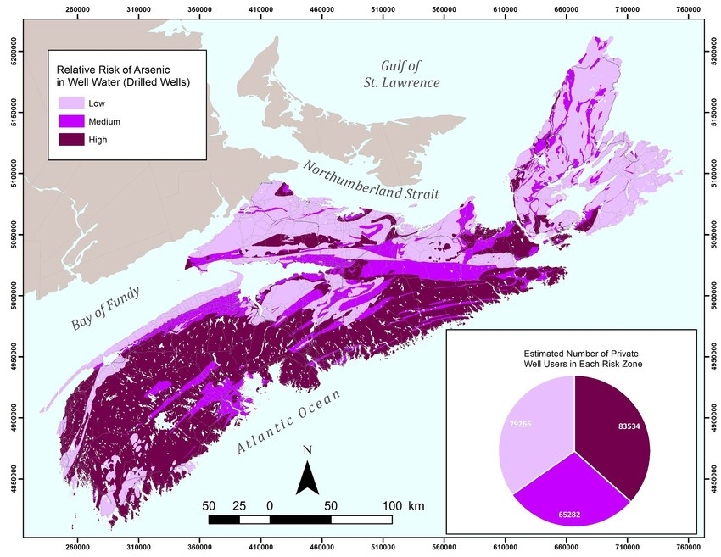
Figure 2.1.5: Arsenic risks in groundwater for Nova Scotia. [33]
Geogenic Sources and Hydrogeochemical Controls of Manganese in Groundwater
Manganese is a naturally occurring element that is widely distributed in the Earth's crust, comprising approximately 0.085% to 0.095% of its composition [35]. This element can enter groundwater systems through the dissolution of manganese-bearing minerals and natural weathering processes.
Manganese commonly exists in multiple oxidation states in the natural environment, with the reduced, water-soluble Mn(II) form and the oxidized, insoluble Mn(IV) form being the predominant species [36]. The primary manganese-containing minerals include pyrolusite (MnO2), manganite (Mn2O3-H2O), hausmannite (Mn3O4), and psilomelane, as well as manganese carbonates (e.g., rhodochrosite, MnCO3), manganese silicates (e.g., rhodonite, MnCa SiO4), and ferromagnesian silicates (e.g., hornblende, olivine) (Earle, 2019b).
In the context of Nova Scotia, the presence of manganese in groundwater has been linked to various geochemical processes, including sedimentary processes, replacement processes, and vein-type processes [3]. The mobilization of manganese is often more pronounced in areas with low oxygen levels or reducing conditions, which favor the release of manganese from mineral phases [37].
The oxidized form of manganese has relatively low solubility under near-neutral pH conditions, leading to the formation of manganese precipitates at higher pH levels in the presence of oxygen or carbonate [38]. Elevated manganese concentrations in groundwater are typically associated with less evolved groundwater chemistry, often near shallow water tables. Additionally, increased aquifer residence time and higher total dissolved solids can enhance the dissolution and mobilization of manganese [39].
The prevalence of manganese contamination in groundwater is a significant concern in various regions. In Nova Scotia, for example, 22.5% of well water samples exceeded the Health Canada's maximum allowance for manganese [40] (Figure 2.1.7). Unlike some other contaminants, manganese contamination is a concern in both bedrock and superficial aquifers in the sedimentary basins due to the specific geochemical conditions [40]. Similar issues have been reported in the Northeastern United States, the province of Quebec (Canada), West Bengal State (India), and Bangka Island (Indonesia) [8,41,42].
- Add policies
Understanding the geogenic sources, mobilization processes, and hydrogeochemical controls of manganese in groundwater is crucial for developing effective strategies to mitigate and manage this persistent environmental issue.


Figure 2.1.6: Red areas are representative of highest population densities that may be consuming water from domestic wells with elevated manganese concentrations [42].
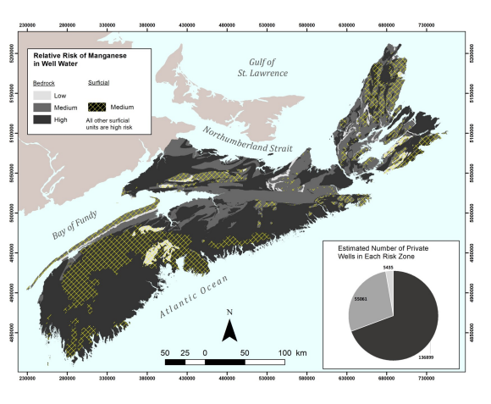
Figure 2.1.7: Mn contamination risk for Nova Scotia, Canada [3].
Health Impacts of Metal Contamination in Groundwater-Derived Drinking Water
The contamination of groundwater with various metals poses a significant public health concern due to the detrimental health effects that can arise from the consumption of metal-laden drinking water. This section will focus on the health implications associated with the specific metals discussed previously, with a particular emphasis on vulnerable populations.
Lead contamination in well water is a grave health issue. When consumed, lead can accumulate in the body over time and has a detrimental impact on the developing nervous systems of young infants, children, and pregnant women [43]. Elevated lead exposure can lead to neurotoxic effects, including cognitive function impairment, developmental delays, learning disabilities, decreased IQ, and behavioral problems in both children and adults.
A prominent example of the consequences of lead contamination in drinking water is the Flint, Michigan Water Crisis of 2014, where the effect of widespread lead poisoning was observed, particularly among young children [44]. In response to this public health issue, the United States Environmental Protection Agency has proposed regulations to replace lead water pipes in cities across the country within the next 10 years, underscoring the priority placed on addressing lead contamination in drinking water [45]. The total cost of lead contamination is substantial, encompassing healthcare expenses, structural changes, environmental regulatory measures, and the immeasurable impact on the affected individuals' developmental outcomes and future productivity [43].
- Specify relevant policies that have been developed due to lead.
Copper contamination in drinking water can also pose health risks, primarily manifesting as gastrointestinal symptoms such as nausea, vomiting, and diarrhea upon acute exposure [46]. Prolonged exposure to elevated copper levels may result in long-term effects, including liver and kidney damage, particularly in individuals with pre-existing liver or kidney conditions or genetic disorders that impair copper metabolism (e.g., Wilson's disease) [47]. Infants and young children are considered a high-risk group due to their higher per-unit-body-weight water consumption.
While iron contamination in well water primarily results in aesthetic issues, such as unpleasant tastes, metallic odors, and discoloration [24,48], excessive intake of iron can cause gastrointestinal discomfort, including cramps, abdominal pain, and diarrhea.
Likewise, the ingestion of zinc-contaminated drinking water can lead to gastrointestinal disturbances, including nausea, vomiting, and abdominal cramps [49]. Prolonged exposure to high levels of zinc in drinking water can also interfere with the absorption of other essential nutrients, such as copper and iron, leading to nutritional deficiencies.
Cadmium contamination in drinking water is particularly concerning, as it can cause kidney damage, including tubular dysfunction and renal failure, even with short-term exposure [50]. Long-term, cadmium is a classified carcinogen, and prolonged exposure has been associated with an increased risk of lung and prostate cancer. Additionally, cadmium can accumulate in bones, leading to osteoporosis and the weakening of the skeletal system [51].
The understanding of these health impacts, particularly on vulnerable populations, is crucial for the development of effective strategies to mitigate and manage metal contamination in groundwater-derived drinking water sources.

Health Impacts of Uranium Contamination in Groundwater-Derived Drinking Water
Uranium exposure through the direct ingestion of contaminated well water is considered the primary route of exposure for human consumers [52]. According to the United States Environmental Protection Agency (EPA), uranium accounts for approximately 99% of the toxicological and radiological dose to individuals consuming uranium-tainted drinking water [53]. Consequently, the EPA has expressed concerns regarding the potential toxicological and radiological risks posed to human health by uranium in drinking water sources.
The current EPA regulatory limit for uranium in drinking water is set at 30 μg/L. However, there is ongoing scientific debate regarding the appropriate safe threshold, with some studies suggesting that uranium concentrations 2.5 to 38 times higher than the current limit may still be considered protective against long-term kidney-related health hazards [53].
Uranium is primarily eliminated from the human body through the kidneys. As a result, the prolonged exposure to elevated levels of uranium in drinking water can lead to direct damage to the renal tubular cells, impaired kidney function, decreased filtration and excretion of waste products, electrolyte imbalances, and the development of chronic kidney disease [54]. The accumulation of uranium in the kidneys can induce inflammation, oxidative stress, and alterations in cellular metabolism, ultimately resulting in renal tubular dysfunction and acute kidney injury. This issue is particularly prevalent in northern Sri Lanka, where the local hydrogeochemistry has elevated levels of uranium and cadmium, contributing to a higher prevalence of chronic kidney disease affecting 2-3% of the adult population [53].
Furthermore, as a radioactive element, the ionizing radiation emitted during the decay of uranium can directly damage DNA, potentially leading to an increased risk of certain cancers, such as leukemia, kidney cancer, and lung cancer [52,54]. The precise mechanisms involved in uranium-induced carcinogenesis are complex, involving both direct DNA damage and indirect effects mediated by oxidative stress, inflammation, and disruption of cellular processes.
Evidence also suggests that uranium exposure can adversely impact reproductive health. In men, uranium exposure has been associated with decreased sperm quality and altered hormone levels. In women, uranium exposure during pregnancy may pose risks to the developing fetus, including lower fetal growth, developmental abnormalities, and an increased risk of premature birth [55]. Additionally, uranium exposure has been linked to an increased incidence of twin births.
Uranium can also accumulate in the bone tissue, with approximately 90% of the absorbed uranium remaining in the human body for up to 1.5 years [56]. The long-term health implications of this bone accumulation require further research.
The substantial societal costs associated with uranium contamination in drinking water include healthcare expenses for the diagnosis and management of long-term conditions, such as kidney disease and cancer, as well as productivity losses due to illness, long-term care, and the environmental remediation necessary to mitigate and prevent further damage.
- Add relevant policies of U due to contamination created because of human health impacts
Addressing the health impacts of uranium contamination in groundwater-derived drinking water is a critical public health priority, requiring rigorous scientific research, evidence-based policymaking, and comprehensive risk mitigation strategies to protect vulnerable populations.

Health Impacts of Arsenic Contamination in Groundwater-Derived Drinking Water

Arsenic is a well-established carcinogen, and its genotoxic properties disrupt DNA repair mechanisms, leading to genetic alterations and the development of cancerous cells (Kapaj et al., 2006). Exposure to arsenic-contaminated drinking water has been associated with an increased risk of several types of cancer, including skin, bladder, lung, and kidney cancer.

One of the primary dermatological manifestations of high-level arsenic exposure is the development of arsenic-induced dermatosis, characterized by hyperpigmentation and skin lesions, ranging from hyperkeratosis to more severe skin cancer [58]. Furthermore, arsenic can cross the blood-brain barrier and accumulate in the central nervous system, leading to neurotoxic effects.

Research suggests that chronic arsenic exposure is also related to an increased risk of cardiovascular disease, including the development of atherosclerosis, hypertension, heart attacks, and s\trokes [50]. Arsenic-induced oxidative stress, inflammation, endothelial dysfunction, and contributions to the pathogenesis of atherosclerosis are proposed as the underlying mechanisms.

In addition to the carcinogenic and cardiovascular effects, arsenic exposure has been linked to respiratory health issues. Inhalation of arsenic-containing particles or dust can lead to respiratory tract irritation and the development of chronic respiratory conditions [59].

Arsenic exposure, particularly during the prenatal and early developmental stages, has been associated with neurological and developmental impairments. Arsenic can cross the blood-brain barrier and accumulate in the central nervous system, leading to neurotoxic effects and impaired cognitive function, as well as increased infant mortality [60,61].

Furthermore, evidence suggests that arsenic can disrupt normal endocrine functioning, interfering with hormone synthesis, release, and signaling pathways, leading to the impairment of various hormonal systems, including the thyroid and reproductive systems (Kapaj et al., 2006).

It is important to note that even low levels of arsenic exposure over prolonged periods can pose significant health risks, and inorganic arsenic compounds are generally more toxic than organic arsenicals, with trivalent arsenite being more toxic than pentavalent arsenate (Kapaj et al., 2006).

The substantial societal costs associated with arsenic contamination in drinking water include the expenses related to the diagnosis, treatment, and long-term management of arsenic-related health conditions, such as cancer, severe skin disorders, cardiovascular diseases, and neurological impairments. Additional costs may encompass productivity losses, long-term care for individuals with chronic conditions, and the implementation of public health interventions to address arsenic contamination and ensure access to safe drinking water.
- Add relevant policies of Mn due to contamination created because of human health impacts

Mitigating the health impacts of arsenic contamination in groundwater-derived drinking water is a critical public health priority, necessitating comprehensive scientific research, evidence-based policymaking, and the development of effective strategies to safeguard vulnerable populations.

Health Impacts of Manganese Contamination in Groundwater-Derived Drinking Water
Manganese is an essential micronutrient that plays a crucial role in various physiological processes, including the development and maintenance of nerve and immune functions, as well as enzyme regulation [41]. However, prolonged exposure to elevated levels of manganese can lead to significant adverse health effects, particularly in infants, children, and the elderly.
At lower doses, manganese contamination in drinking water is primarily associated with undesirable aesthetic effects, such as bad tastes, odors, and staining of laundry [41]. However, chronic exposure to elevated manganese levels can result in more serious neurological consequences.
Numerous studies have reported that prolonged manganese exposure can lead to neurobehavioral changes, including mood swings and irritability, as well as more severe neurological impairments, such as motor dysfunction, movement and coordination difficulties, muscle rigidity, tremors, memory deficits, and cognitive impairment resembling Parkinson's disease [61,62]. The developing brains of infants and children are particularly vulnerable to the neurotoxic effects of manganese, as the metal can cross the placenta and accumulate in the brain, leading to decreased cognitive abilities, motor deficits, and behavioral issues [61].
In addition to the neurological effects, manganese exposure has also been associated with hepatotoxicity, resulting in liver dysfunction and damage due to the metal's tendency to accumulate in the liver [41]. Some studies have also suggested a potential impact on pancreatic function, leading to symptoms resembling diabetes [41].
Manganese exposure has also been shown to have adverse effects on the cardiovascular system. Human and animal studies have indicated that high levels of internal manganese exposure can significantly alter cardiac functions, including increased heart rates, inhibition of myocardial contractions, vasodilation, and the induction of hypertension, which may be linked to direct effects on mitochondrial functions [63].
The elderly population is also a group of particular concern regarding manganese toxicity, as the accumulation of the metal over time can exacerbate the development of idiopathic Parkinson's-like symptoms [64]. Additionally, gender, ethnicity, genetics, and pre-existing conditions, such as chronic liver disease, have been identified as potential factors influencing individual susceptibility to manganese toxicity [63].
The growing recognition of the toxicity and biochemical impacts of manganese accumulation has led to increased governmental concern and the development of regulatory guidelines to address manganese contamination in drinking water, particularly in regions like Nova Scotia, the United States, Korea, Italy, and China [41,63].
- Is there Mn policies that have been passed due to overexposure? (Other then the general limits)
The cost of health damage associated with manganese contamination varies depending on factors such as the concentration, duration of exposure, and individual susceptibility. These costs include healthcare expenses related to diagnosis, treatment, management, detoxification, and care for critically ill individuals, as well as societal costs, such as productivity losses and the implementation of public health interventions.
Differential Health Impacts and Vulnerable Populations Affected by Groundwater Metal Contamination
Children, pregnant women, the elderly, and individuals with pre-existing health conditions or compromised immune systems are particularly vulnerable to the adverse health effects associated with metal contamination in groundwater-derived drinking water.
Children, due to their developing bodies, neurological systems, and organs, are highly susceptible to the detrimental impacts of exposure to heavy metals such as lead, arsenic, and manganese. This can lead to a range of developmental issues, including neurological impairments that can result in cognitive deficits, learning disabilities, and behavioral problems, which can persist into adulthood and negatively impact their quality of life [50,61]. Exposure to manganese can disrupt regular brain development and affect attention, memory, and intellectual functioning [61], while arsenic exposure during critical stages of brain development can cause permanent neurological impairments, such as decreased IQ, learning difficulties, and behavioral issues [60]. Metal contamination can also cause growth deformities and developmental delays in children, with exposure during critical growth stages leading to delays in motor skills and overall growth parameters, as well as malformed limbs and other deformities [61]. Young children, particularly between 6 months and 6 years of age, are especially vulnerable to lead exposure due to their higher rate of hand-to-mouth behavior, increasing the likelihood of ingesting lead [44].
Pregnant women and their developing fetuses are also highly vulnerable to metal contamination in well water due to the potential for placental transfer, where metals such as lead, arsenic, and manganese can cross the placenta and reach the developing fetus [61]. This can lead to birth defects, including neural tube defects, limb abnormalities, and other health issues that can have long-term consequences for the child. Arsenic exposure during pregnancy has also been associated with an increased risk of pregnancy complications, such as preterm birth and preeclampsia [19].
The elderly and individuals with compromised immune systems or pre-existing health conditions are more susceptible to the adverse effects of metal contamination in groundwater-derived drinking water [65]. The vulnerability of the elderly is often exacerbated by age-related physiological changes and decreased resilience, particularly for those above 65 years of age [66]. Lead exposure can further impact cognitive function in individuals with age-related cognitive decline [67], while manganese exposure can exacerbate such age-related cognitive and motor deficits (Parmalee & Aschner, 2016). Arsenic exposure can also worsen existing cardiovascular conditions, such as hypertension, atherosclerosis, and congestive heart failure, leading to an increased risk of heart attacks and strokes [50,60]. Individuals with pre-existing respiratory, kidney, or liver diseases are also more vulnerable to the further compromise of their organ function due to the effects of metal contaminants [51,65].
Socioeconomic factors can also amplify the adverse health impacts of groundwater metal contamination, as individuals from lower socioeconomic backgrounds may face increased vulnerabilities due to limited access to proper healthcare, inadequate housing, and lack of alternative water remediation options.
- Add in policy gaps
The differential health impacts and vulnerability of specific populations underscore the need for targeted public health interventions, enhanced monitoring, and the development of effective mitigation strategies to protect the most vulnerable members of communities affected by groundwater metal contamination.

Health Effects of Metal Contamination in Well Water
The toxicity effects of metal contamination in groundwater can be acute, chronic or cumulative. Acute toxicity refers to the immediate short-term health consequences that occur after a single high dose of a contamination [49]. Exposure typically occurs over a relatively brief period ranging from minutes to hours and acute effects/symptoms, manifest quickly and have an immediate onset. Examples include gastrointestinal issues from sink water contaminated with its copper leading to nausea, , diarrhea and destructing normal digestive processes or high levels of zinc which cause abdominal pain, nausea and diarrhea [68]. Another acute effect is respiratory problems from metal contaminated water vapors when showering. Aluminum, for example vomiting, leads to wheezing coughing and respiratory distress [69].
Chronic toxicity is the long-term effects that develop over an extended period of continuous or repeated exposure to metal contamination [65]. The time frame ranges from months to years depending on the substance and exposure duration. Said effects develop gradually and may become apparent after a significant duration of exposure. A common symptom of this is organ damage. Cadmium exposure leads to cadmium accumulations in kidneys and thus causes progressively renal damage [70]. Hexavalent chromium damages the respiratory, liver and kidneys over time.
Cumulative toxicity refers to the gradual accumulation of metal contamination in the body because of repeated and continuous prolonged exposure [69]. The body may not be able to eliminate or excrete certain metals thus they build up over time and lead to an increasing risk of chronic health conditions. The primary root of exposure is often through ingestion [65]. Metals are consumed, absorbed in the bloodstream through the gastrointestinal tract and distributed throughout the body. This buildup leads to increased health risks and potential development of chronic diseases. Some metals have affinities for certain organs and thus buildup of toxin levels occurs in specific tissues [49]. This buildup is known to cause carcinogenic effects, especially with arsenic, cadmium and chromium; and systematic effects over various body systems.
- Add in policy gaps

Long-term Implications and Potential for Synergistic Effects of Groundwater Metal Contamination
The simultaneous exposure to multiple metal contaminants in groundwater-derived drinking water can result in synergistic effects, where the combined toxicity is greater than the sum of the individual metal exposures [67]. The interaction of different metals within the body can lead to potential additive toxic effects, as the presence of one metal may enhance the toxicity of another, resulting in more severe health consequences.
The mechanisms underlying these synergistic effects can be attributed to various processes, including increased absorption, altered metabolism, and enhanced cellular damage [71]. For example, the co-exposure to lead and cadmium has been shown to have a synergistic effect on the kidneys, with the combined toxic impact being amplified compared to the individual effects of each metal, leading to a higher risk of renal dysfunction and severe kidney damage [50]. Similarly, the combined exposure to arsenic and chromium has been associated with synergistic effects on the lungs, increasing the likelihood of cancer development beyond the additive effect of each metal alone [50].
One mechanism by which synergistic effects can occur is through the enhancement of the bioavailability and absorption of one metal by the presence of another [71]. This can happen if one metal disrupts the body's protective barriers, enabling easier entry for another metal into the tissues. Another mechanism involves the amplification of cellular damage, where the presence of one metal can intensify the damage caused by another, through processes such as oxidative stress, DNA damage, disruption of cellular signaling pathways, or interference with enzyme functioning [67], Additionally, synergistic effects can arise from the influence of one metal on the metabolism and elimination of another, leading to the accumulation of both metals in the body and prolonged exposure, which further increases their toxic effects [67].
The presence of multiple metal contaminants in groundwater can result in both cumulative and synergistic effects on human health. Exposure to a combination of metals may exhibit not only the synergistic enhancement of individual toxic effects but also the cumulative buildup of these metals in the body over time [69]. This combined impact increases the severity of long-term health problems, such as the synergistic effect of lead and cadmium on kidney damage, as well as the cumulative accumulation of these metals in the tissues [50]. Another example is the synergistic effect of arsenic and lead on neurodevelopmental impairments in children, leading to more severe neurological deficits [50].
The potential for synergistic and cumulative effects of groundwater metal contamination highlights the importance of comprehensive risk assessment and the development of targeted mitigation strategies to address the complex interplay of multiple metal pollutants and their long-term health implications for affected communities.
- Add in policy gaps
**** Add conclusion
VII. Conclusion
- Summary of Key Findings
  - Recap metals contamination sources
  - policy recommendations for managing groundwater contamination by lead, uranium, manganese, and arsenic.
  - Policy gaps: related to naturally occurring contaminants.
  - Discuss how policy can mitigate health risks:
  - Areas where current policies are lacking or could be improved.
  - policy recommendations for managing groundwater contamination by lead, uranium, manganese, and arsenic.
    - Specifically private well owner usage, climate change,
  - Address how policy should reflect environmental science: interactions of geogenic contaminate cycles
- Future Research Directions
  - Long-term monitoring programs.
  - Strategies for community participation in monitoring and remediation efforts to reduce human health effects
  - Development of predictive models for contaminant behaviors.
- Closing
  - the importance of integrating scientific understanding with policy to protect public health and environmental integrity
  - Call to action

